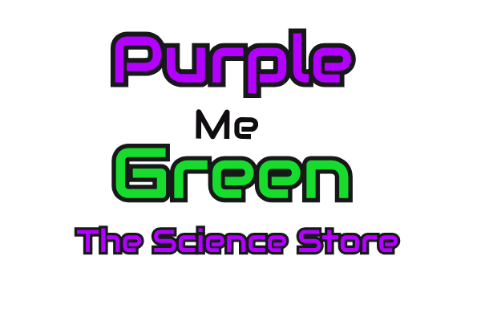
Purple Me Green Reading Log
Read during this time away and earn some animal time! If you read 30 minutes per day for 14 days for a total of 420 minutes, you will earn time to hold an animal of your choice when we do open. Reading for ages 3 and up! Animals included are the guinea pigs, lizards, Sansa the corn snake, or Trixie the box turtle. Each reading log includes one free hour in our Green S.T.E.M. Play Space and time to hold one animal of your choice when we do open! Reading dates must be between March 23rd and April 23rd, unless our time is extended. Limit one log per child. Limit one free 1 entry per child and 1 free animal hold.
One the back of this sheet, please draw your favorite animal or scene from your favorite story! This will earn you a 10% off one item in the store of $10 or more! Coupon expires May 10th, 2020 and can only be used in the store not for online- or Purple Truck Order bordering unless we are quarantined longer then April 7th, 2020. Then I will post a revision for coupon and reading logs.
Date | Name of Book (s) | Minutes read | Parent initial

Purple Me Green
The Science Store
5 Woodfield Mall Dr, E111A, Schaumburg, IL 60173
www.purplemegreen.com

