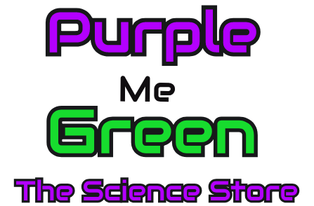

Bring this flyer in from November 4th through December 31st, 2018 or show it on your mobile device at check out and Purple Me Green will donate 10% of your total purchase to your organization listed below. See below for details.

November 5th through December 31st
10% of Sales! And / Or $10 for Every Birthday Party!

Fundraiser in support for:

Purple Me Green, The Science Store provides science toys, science classes, science birthday parties, and eco-friendly products.
Locally and family owned.

The Arboretum of South Barrington
100 W. Higgins Rd., F-30
(Across from DSW Shoes)

Fundraiser valid only on dates listed on flyer at Purple Me Green located at The Arboretum of South. Fundraiser valid with 501c organizations and/or non-profit schools who register with Purple Me Green for this Fundraiser! Only 501c organizations and non-profit schools are eligible to participate in Purple Me Green’s fundraiser program. Purple Me Green will donate 10% (ten percentage) of all sales to the organization made when this flyer is presented at check out. If sales made online, please indicate that it is a fundraiser for your school in the fundraiser section. Tax, gratuity, shipping and gift card(s) are excluded from the donation. Offer valid for any retail item located in the store or online. A donation of $10 will be made for each birthday party deposit paid for by February 15th, 2019 and scheduled by March 15th, 2019. Birthday party deposit is non-refundable. Open play not included in the fundraiser. Not valid for third-party delivery. For information about the 501c organization participating in the fundraiser, please contact Purple Me Green.

